- IDENTITAS
NIM : 2403001
Nama Lengkap : Siti Sa’adah
Kelas : D3 TI 2A
Program Studi : D3 TEKNIK INFORMATIKA
Jurusan : TEKNIK INFORMATIKA

- HASIL PRAKTIKUM/ TUGAS
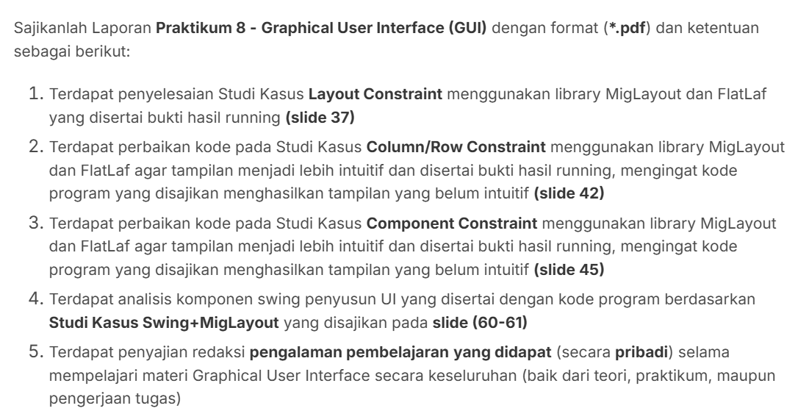

- Layout constraint
- Kode program 1
package FiksTugasIniMah;

import java.awt.Dimension;
import javax.swing.JButton;
import javax.swing.JFrame;
import javax.swing.JLabel;
import javax.swing.JPanel;
import javax.swing.SwingUtilities;

import net.miginfocom.swing.MigLayout;

public class ContohLayoutConstraint {

public static void main(String[] args) {
SwingUtilities.invokeLater(() -> {

JFrame frame = new JFrame("Layout Constraints Tisa");
frame.setDefaultCloseOperation(JFrame.EXIT_ON_CLOSE);
frame.setPreferredSize(new Dimension(500, 400));

String layoutConstraints = "fill, debug, insets 20, hidemode 3";

JPanel panel = new JPanel(new MigLayout(layoutConstraints));

JButton button1 = new JButton("Button 1");
JButton button2 = new JButton("Button 2");
JButton button3 = new JButton("Button 3");
JLabel statusLabel = new JLabel("Button 2 Terlihat");

panel.add(button1, "w 100, h 50");
panel.add(button2, "w 100, h 50, wrap");
panel.add(button3, "span 2, growx, h 50, wrap");
panel.add(statusLabel, "span 2, align center, gaptop 20");

button1.addActionListener(e -> {
boolean isVisible = button2.isVisible();
button2.setVisible(!isVisible);

if (!isVisible) {

statusLabel.setText("Button 2 Terlihat Kembali");
} else {

statusLabel.setText("Button 2 Disembunyikan (Ruang Kosong Dilipat)");
}

panel.revalidate();
panel.repaint();
});

frame.add(panel);
frame.pack();
frame.setLocationRelativeTo(null);
frame.setVisible(true);
});
}
}

- Run

- Hasil run
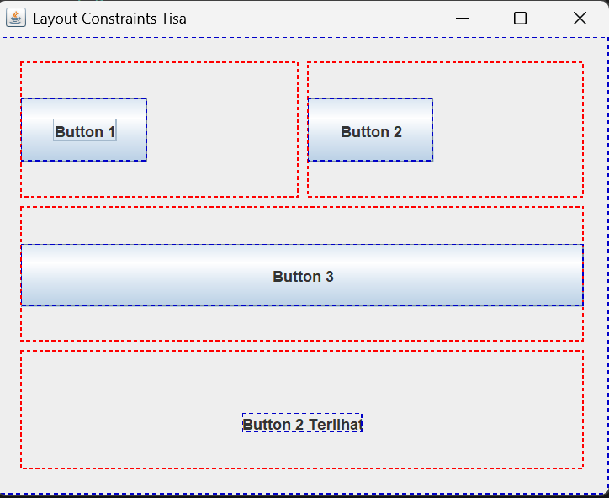
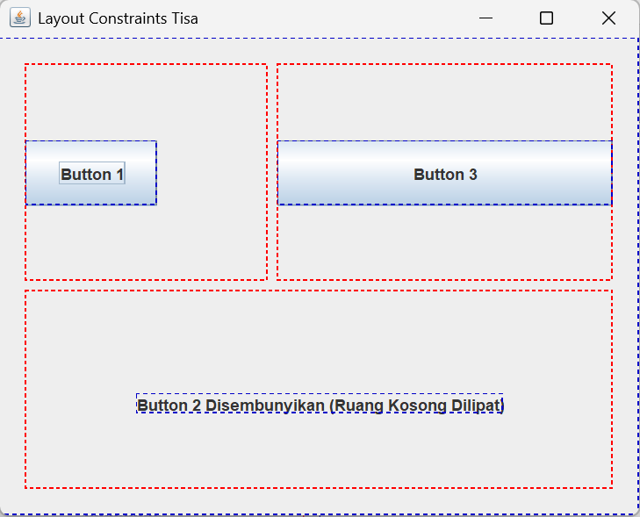

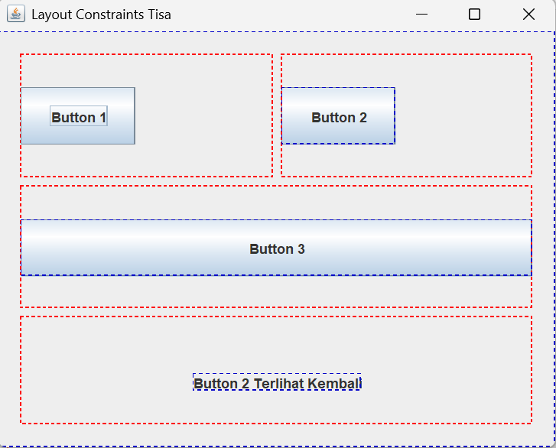

- Kode program 2
package FiksTugasIniMah;

import java.awt.Dimension;
import javax.swing.JButton;
import javax.swing.JFrame;
import javax.swing.JLabel;
import javax.swing.JPanel;
import javax.swing.SwingUtilities;

import net.miginfocom.swing.MigLayout;
import com.formdev.flatlaf.FlatLightLaf;

public class ImplementasiContohLayoutConstraintFlatLaf {

public static void main(String[] args) {
SwingUtilities.invokeLater(() -> {

try {
FlatLightLaf.setup();
} catch (Exception ex) {
System.err.println("Gagal mengatur FlatLaf Look and Feel: " + ex);
}

JFrame frame = new JFrame("Implementasi Layout Constraints Tisa");
frame.setDefaultCloseOperation(JFrame.EXIT_ON_CLOSE);
frame.setPreferredSize(new Dimension(500, 400));

String layoutConstraints = "fill, debug, insets 20, hidemode 3";

JPanel panel = new JPanel(new MigLayout(layoutConstraints));

JButton button1 = new JButton("Button 1 (Toggle)");
JButton button2 = new JButton("Button 2");
JButton button3 = new JButton("Button 3");
JLabel statusLabel = new JLabel("Button 2 Terlihat");

panel.add(button1, "w 100, h 50");
panel.add(button2, "w 100, h 50, wrap");
panel.add(button3, "span 2, growx, h 50, wrap");
panel.add(statusLabel, "span 2, align center, gaptop 20");

button1.addActionListener(e -> {
boolean isVisible = button2.isVisible();
button2.setVisible(!isVisible);

if (!isVisible) {
statusLabel.setText("Button 2 Terlihat Kembali");
} else {
statusLabel.setText("Button 2 Disembunyikan (Ruang Kosong Dilipat)");
}

panel.revalidate();
panel.repaint();
});

frame.add(panel);
frame.pack();
frame.setLocationRelativeTo(null);
frame.setVisible(true);
});
}
}

- Run

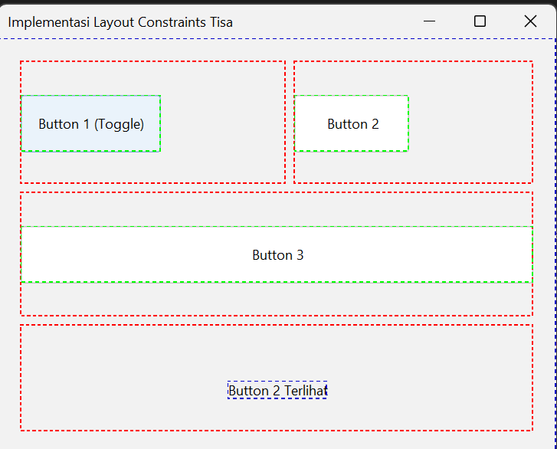
- Hasil Run
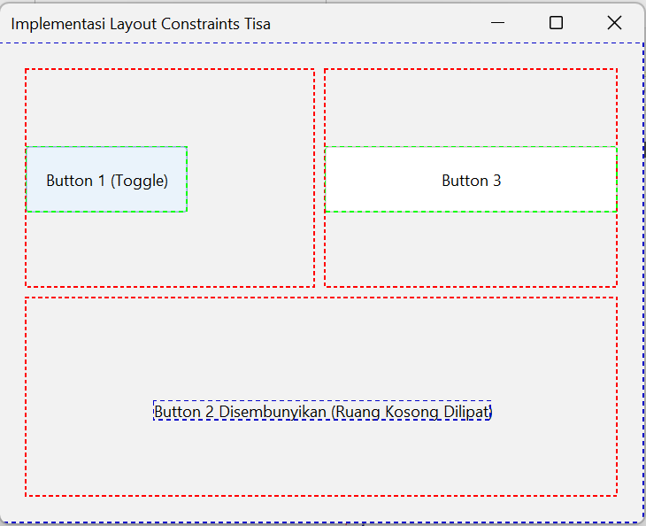

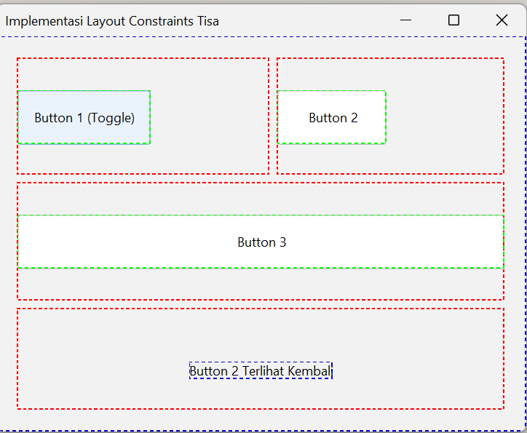

- Column/ Row Constraint

- Component Constrain
- Swing + MigLayout
- Pengalaman pembelajan
Sejujurnya saya tidak faham, saya bingung jadi saya malas

